PROJECT CLV

Student name:Luiz Carlos de Lima Pereira id:TI1013164

1 to know the annual spent, i took the average purchase amount per visit multiplied per 3 that is the number that you go per week then multiplied per 52

The 52 represent the number of weeks in a year,i used it based on the average purchase amount and the number of visits per week

Then with the annual spent i multiple it per the customer lifetime

2

INPUT:# Define variables

customer_start_date <- as.Date("2020-01-01") # Customer start date

customer_lifetime <- as.numeric(difftime(Sys.Date(), customer_start_date, units = "days"))/365 # Customer lifetime in years

avg_purchase_amount <- 6.45 # Average purchase amount

visits_per_week <- 3 # Number of visits per week

profit_margin <- 0.25 # Profit margin as a decimal

# Calculate CLV

annual_spend <- avg_purchase_amount * visits_per_week * 52 # Annual spending at Tim Hortons

annual_profit <- annual_spend * profit_margin # Annual profit at 25% profit margin

annual_revenue <- annual_spend - annual_profit # Annual revenue after subtracting profit

clv <- annual_revenue * customer_lifetime

# Print CLV

cat("The customer lifetime value with a 25% profit margin is $", round(clv, 2), ".", sep="")

OUTPUT:

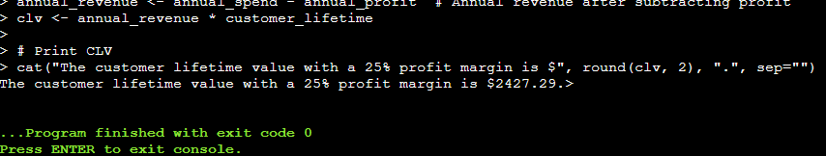

3 INPUT:

# Define variables

customer_start_date <- as.Date("2020-01-01") # Customer start date

customer_lifetime <- 2 # Customer lifetime in years

total_spending <- 2000 # Total spending over 2 years

visits_per_week <- 3 # Number of visits per week

avg_purchase_amount <- total_spending / (visits_per_week * 52 * customer_lifetime) # Calculate average purchase amount

profit_margin <- 0.25 # Profit margin as a decimal

# Calculate CLV

annual_spend <- avg_purchase_amount * visits_per_week * 52 # Annual spending at Tim Hortons

annual_profit <- annual_spend * profit_margin # Annual profit at 25% profit margin

annual_revenue <- annual_spend - annual_profit # Annual revenue after subtracting profit

clv <- annual_revenue * customer_lifetime

# Print CLV

cat("The customer lifetime value is $", round(clv, 2), ".", sep="")

4 INPUT:

# Define variables

customer_start_date <- as.Date("2020-01-01") # Customer start date

customer_lifetime <- as.numeric(difftime(Sys.Date(), customer_start_date, units = "days"))/365 # Customer lifetime in years

avg_purchase_amount <- 6.45 # Average purchase amount

visits_per_week <- 3 # Number of visits per week

# Calculate CLV

annual_spend <- avg_purchase_amount * visits_per_week * 52 # Annual spending at Tim Hortons

clv <- annual_spend * customer_lifetime

# Print CLV

cat("The customer lifetime value is $", round(clv, 2), ".", sep="")

OUTPUT:

